Lambda Logging and error handling

var greets = [

"Hello NFJS!",

"Hello Awesome Serverless!",

"Today is a great day!",

"Go Lambda function!",

"I am expecting miracles",

"Go get it!",

"Twinkle Twinkle Little star!",

"How I wonder what you are",

"Love the serverless!",

"Cool apps using serverless!"

];

exports.handler = (event, context, callback) => {

let greet = greets[Math.floor(Math.random()*10)];

// Context object

console.log('Remaining time: ', context.getRemainingTimeInMillis())

console.log('Function name: ', context.functionName)

console.log('Memory Limit In MB : ', context.memoryLimitInMB)

console.error('Error in the function ')

console.info('Memory Limit In MB : ', context.memoryLimitInMB)

console.warn('Warning in Lambda ')

callback(null, greet);

};

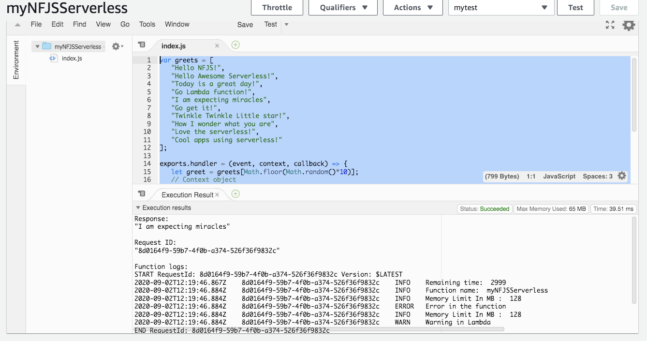

Cloud Watch Logs

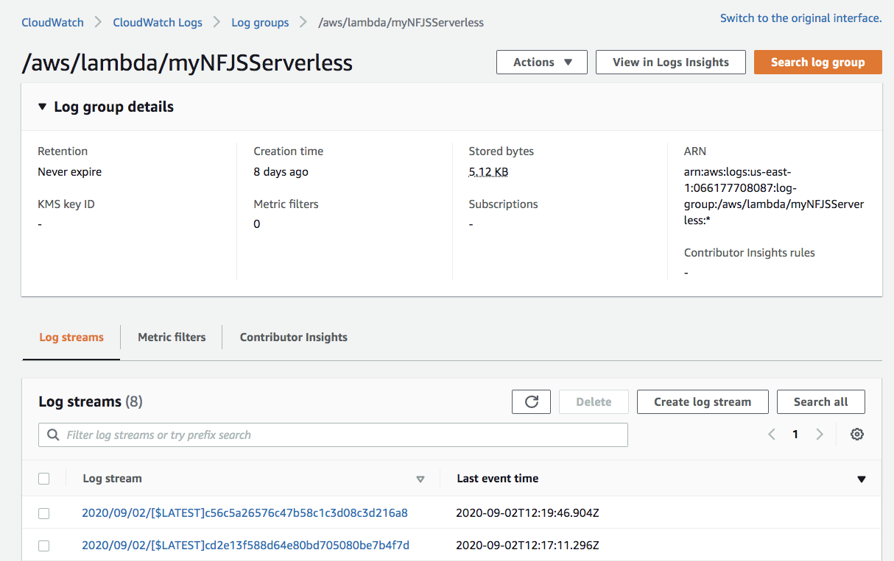

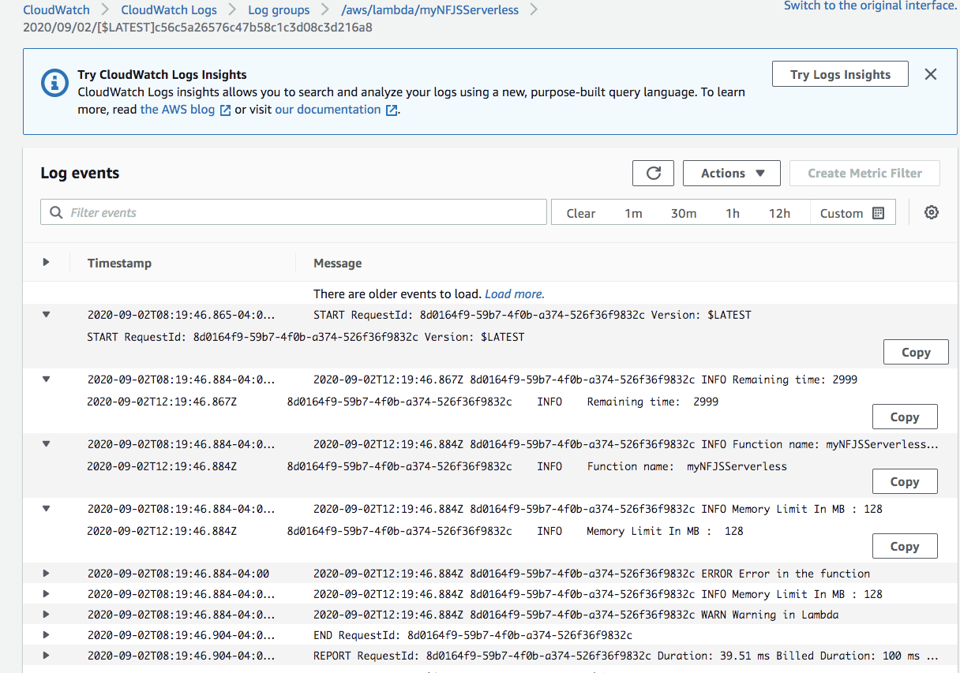

## Add greet to the console

let greet = greets[Math.floor(Math.random()*10)];

console.log(greet)

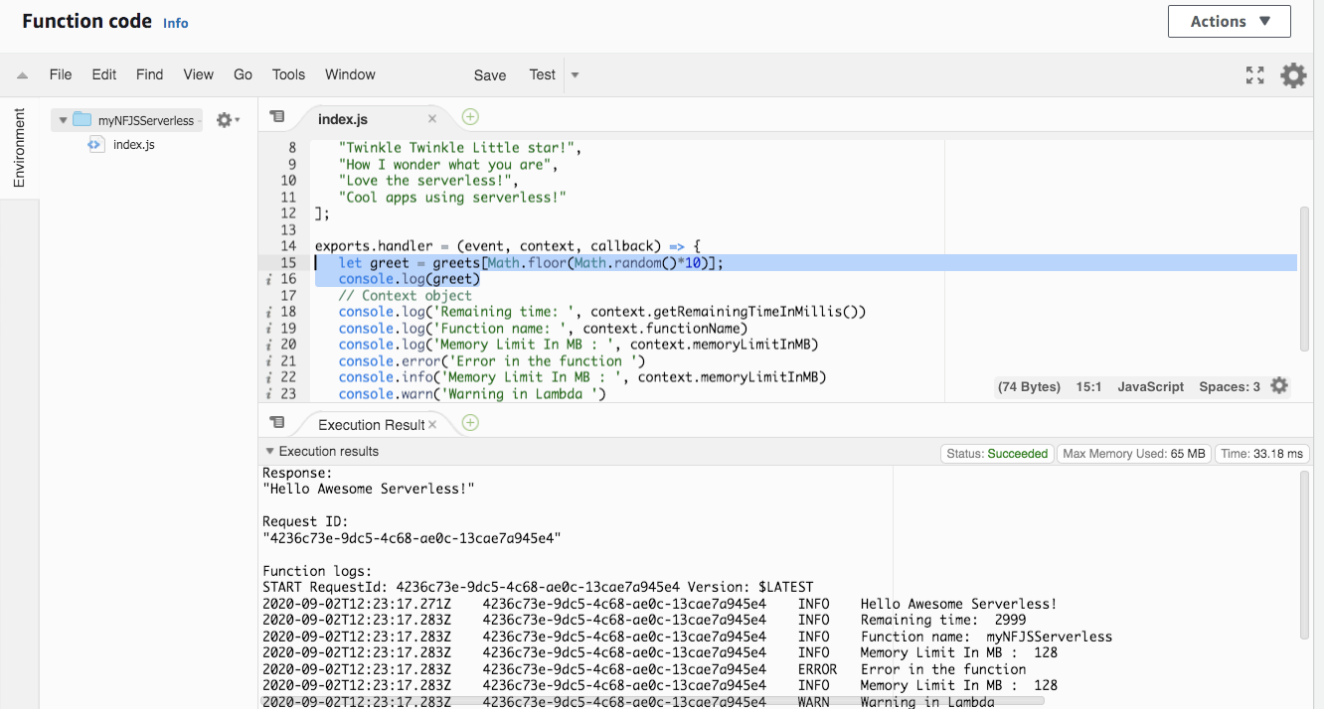

## Throw error message

throw new Error("Error occurred, check the input")

